|  |
| --- |
| * ***Decision Tree Classifer Project - 8*** |

|  |
| --- |
| * ***Objectives*** |

|  |
| --- |
| ***Using Decision Tree Model*** |
| * ***Prediction of the Iphone Purchased*** ***on the basis of*** ***Gender ,*** ***Age , Salary*** |

|  |
| --- |
| * ***To draw insights by performing EDA on the data*** |
| * ***Model building and prediction*** |
| * ***Business Impact*** |

* ***Exploratory Data Analysis on the data*** 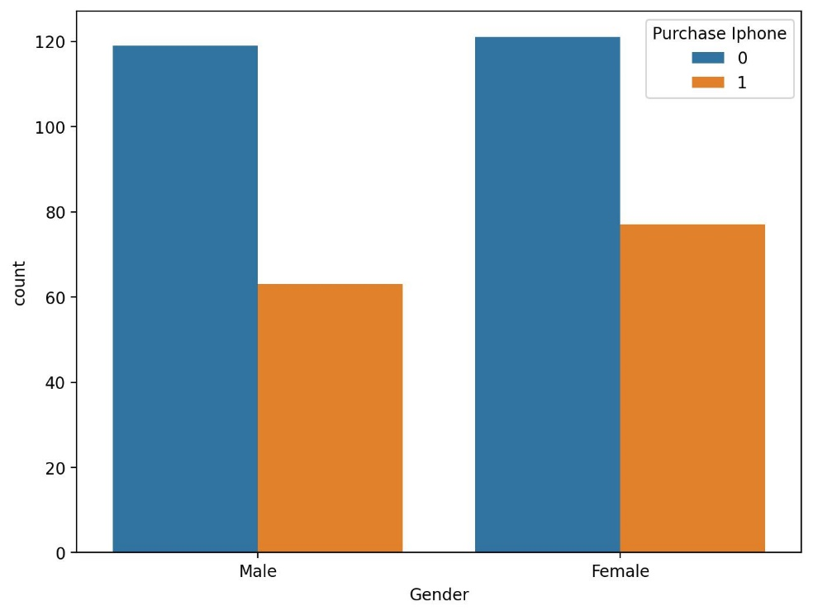

|  |
| --- |
|  |

* ***Out of 198 females, 77 has purchased Iphones while out of 182 males, 63 has purchased Iphones.***
* ***Gender and Salary wise variation in purchase of Iphone***

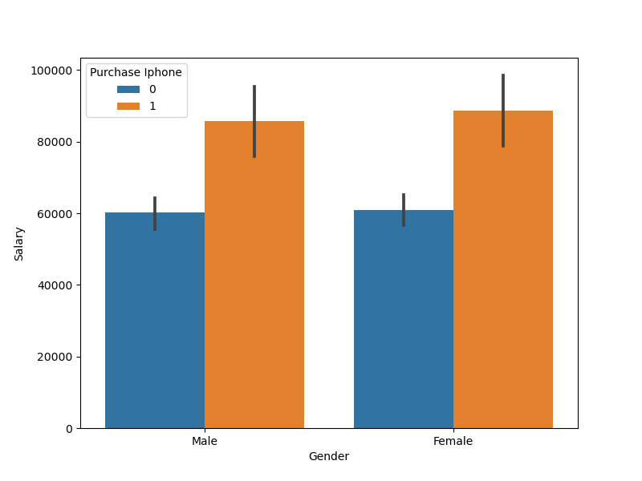

* ***Genders with high salaries are likely to purchase Iphones.***
* ***Gender and Age wise variation in purchase of Iphones***

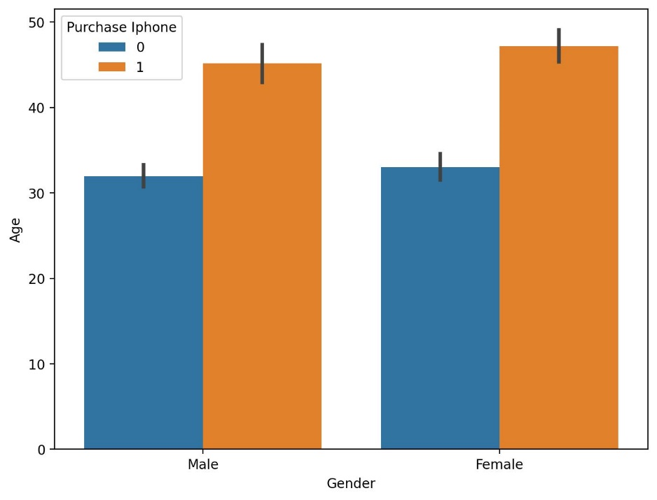

* ***In age of male (31-45)*** ***and female (32-47) group of ages having high salaries have purchased iphones***
* ***Age and Salary wise variation in purchase in Iphone***

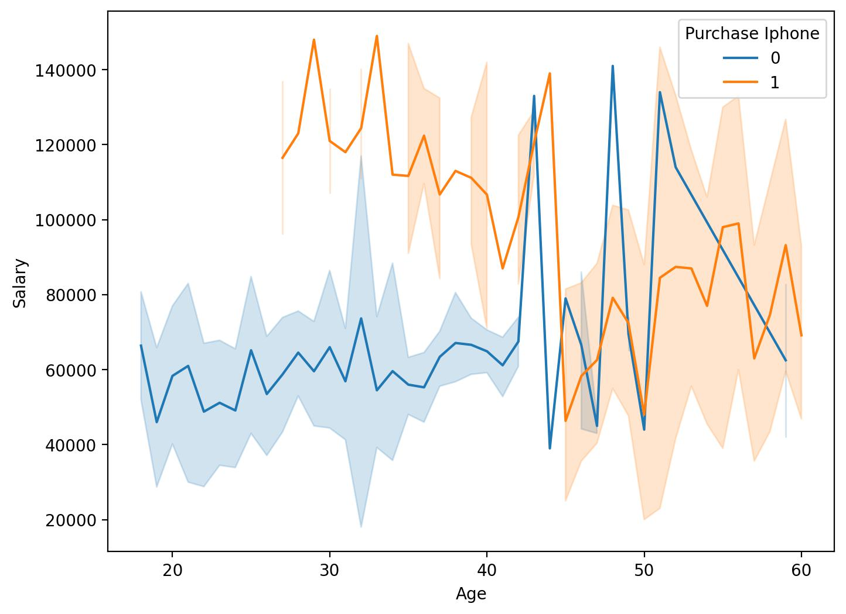

***Normal Distribution***

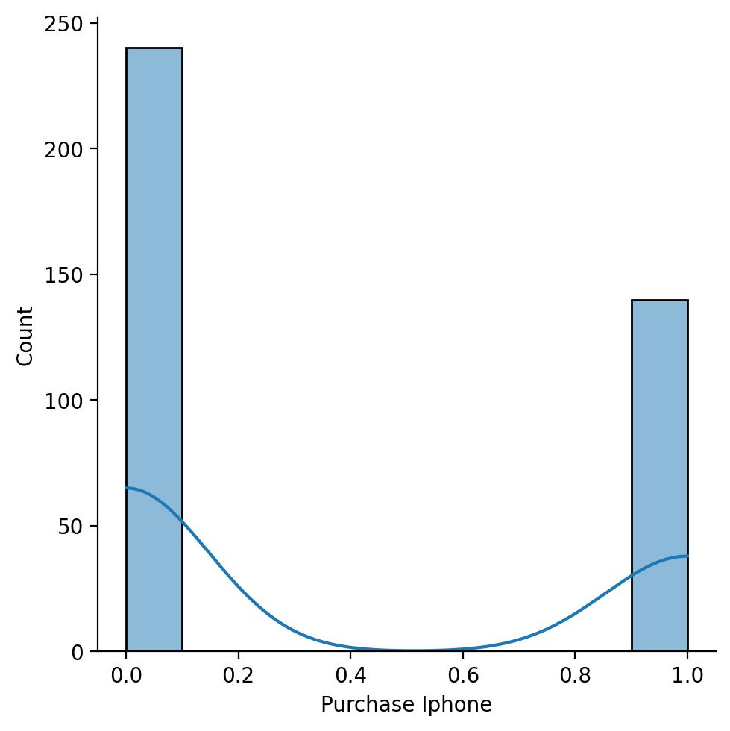

* ***Outliers Detecting by Box plot***

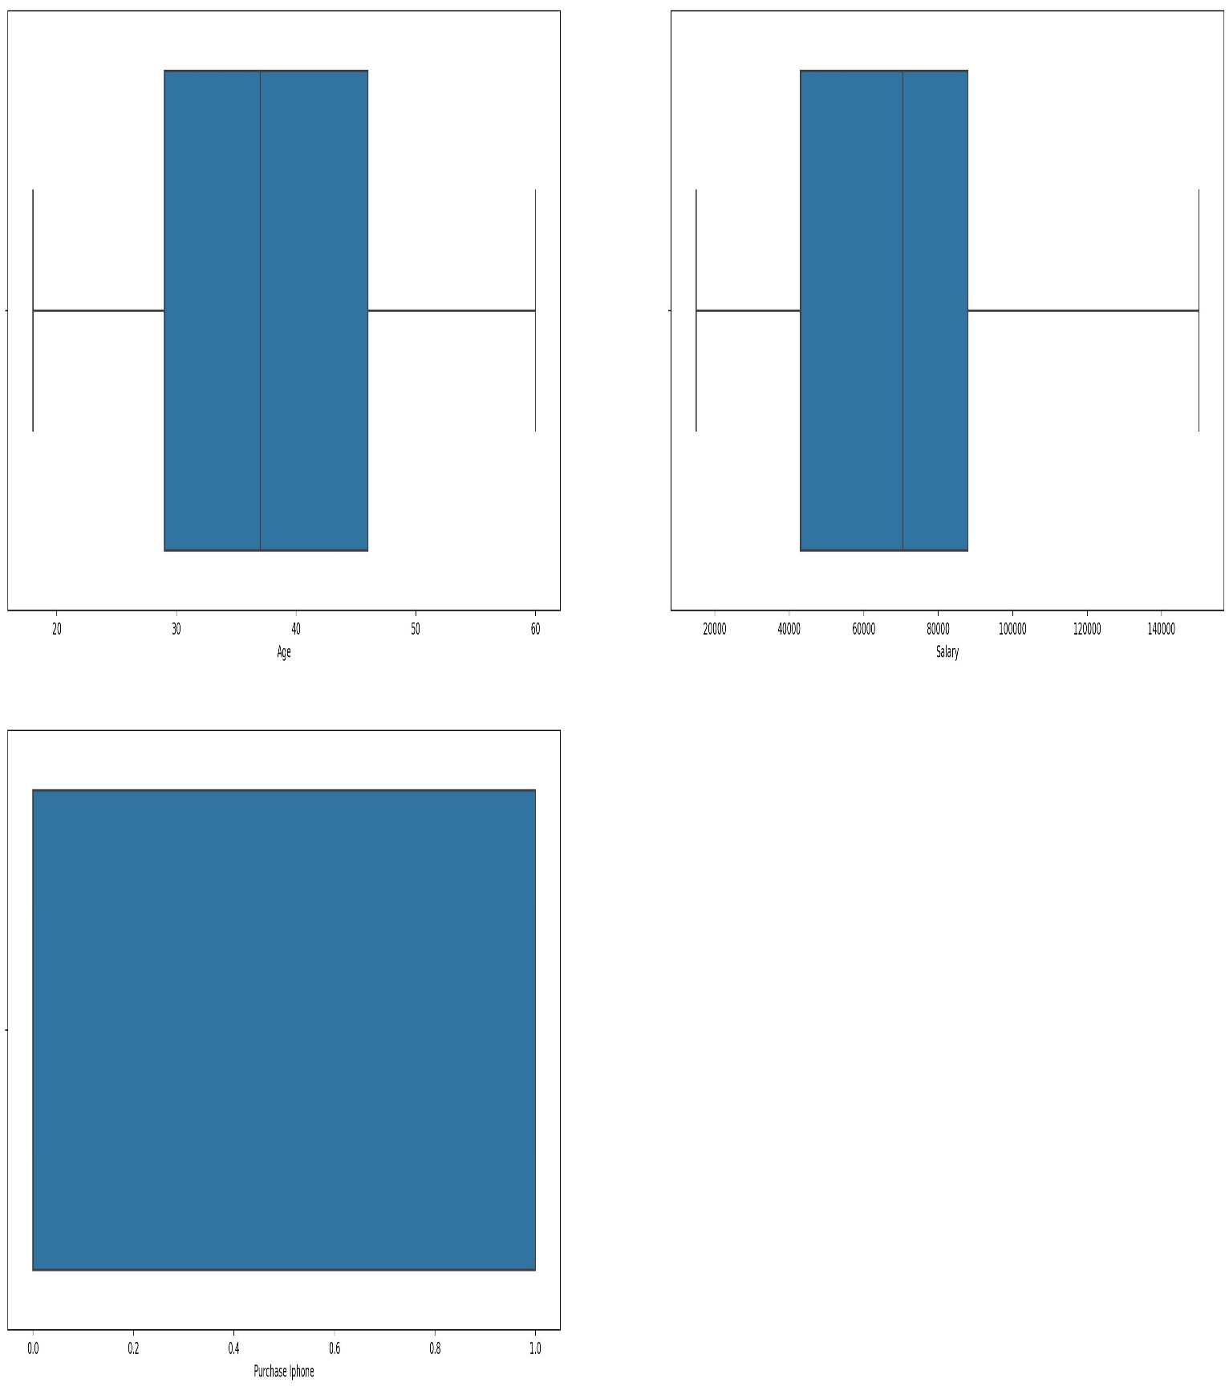

* ***There no outliers in the data***

***The dataset is solved by Decision Tree***

***Accuracy score: 0.83***

* ***Business Impact***
* ***Targeted Marketing Campaigns:***

***Tailor marketing campaigns based on predicted iPhone purchase behavior linked to gender, age, and salary ranges.***

***Maximize advertising efficiency by directing efforts toward demographics more likely to make a purchase.***

* ***Inventory Management:***

***Optimize iPhone inventory levels by aligning stock with predicted demand from specific gender and age groups.***

***Minimize excess stock or shortages, ensuring efficient use of resources and capital.***

* ***Market Positioning:***

***Leverage insights to strategically position iPhones in the market based on demographic preferences.***

***Adjust product features, marketing messages, and distribution channels to align with identified consumer segments.***

* ***Budget Allocation:***

***Allocate marketing budgets more effectively by focusing spending on demographics with higher predicted purchase rates.***

***Maximize the return on investment in marketing initiatives.***

***Customer Retention Strategies:***

***Develop targeted retention strategies for specific demographics to nurture long-term customer relationships.***

***Identify loyalty programs or incentives that resonate with different gender and age groups.***

* ***Competitive Edge:***

***Gain a competitive advantage by leveraging predictive insights to stay ahead of market trends.***

***Continuously refine strategies based on real-time data, positioning the brand as innovative and*** ***customer-centric.***

* ***Financial Forecasting:***

***Improve financial forecasting by integrating predicted iPhone purchase patterns into budgetary planning.***

***Enhance accuracy in revenue projections and resource allocation.***

* ***Brand Perception Enhancement:***

***Shape brand perception by aligning marketing efforts with values and preferences of different demographic segments.***

***Foster a positive and inclusive brand image.***